Serbian-French Innovation Forum 2025
“AI-deas for a better tomorrow: driving societal change”
April 2nd & 3rd, 2025
Belgrade

April 2, 2025
17:00 – 18:00 Conference “Nikola Tesla: France as inspiration”
Speaker: Aleksandar Protic, École Polytechnique
Palace of Science, Kralja Milana 11
April 3, 2025
Serbian – French Innovation Forum
Palace of Serbia, Bulevar Mihajla Pupina 2
Opening Session
09:00 Registration
09:55 Launch by Ms. Jelisaveta Lazarevic, PhD, FEFA Vice Dean & PIPA Alumni
10:00 Opening speech by H.E. Jelena Begovic, PhD, Minister for Science, Technological
Development and Innovation, Republic of Serbia
10:10 Opening speech by H.E. Pierre Cochard, Ambassador of France to Serbia
10.20 Signing of the Memorandum of Cooperation between the Ministry of Science, Technological Development, and Innovation and the French Institute
10:30 Keynote lecture – Ms. Danijela Markovic, CNRS-Thales-Paris-Saclay University « Albert Fert lab »: "Quantum AI or how to teach a quantum machine to compute”
11:00 Coffee break
Roundtables moderated by Jelisaveta Lazarevic, PhD
11:20 - 11:55 Panel n°1 « Artificial Intelligence applications for sustainable and innovative transports »

Speakers:
- Mr. Nenad Mijatovic, PhD, Director of Data Science and AI, Alstom: Focus on public transportation
- Ms. Laurence Bechon, Chief Operating Officer, Software République: Focus on sustainable and connected mobility
- Mr. Aleksandar Bojanic, Regional Director, Airbus: Focus on AI satellite apps for better transports

11:55 - 12:30 Panel n°2 « Artificial Intelligence applications for better health »

Speakers:
- Mr. Jean-François Beraud, Chief Innovation Officer, Advans
- Ms. Aleksandra Dragićević, PhD, Advisor for AI in health, C4IR, Serbia
- Ms. Karmen Stankov, PhD, Professor, University of Novi Sad
12:30 - 13:05 Panel n°3 « Artificial Intelligence applications for energy sector and materials »
Speakers:
- Ms. Ksenija Karić, Head of Business and Strategy, Pulsec
- Ms. Marijana Milicevic, PhD, R&D project leader, Saint-Gobain
- Ms. Heidi Sen, Head of European partnerships, BPI France
13:15 - 14:30 End of the forum and Networking lunch
Mission France
Final Pitch Sessions for 12 finalist startups
Belgrade Science and Technology Park, Veljka Dugosevica 54
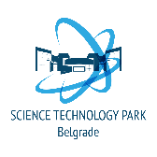
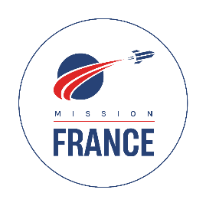

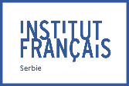

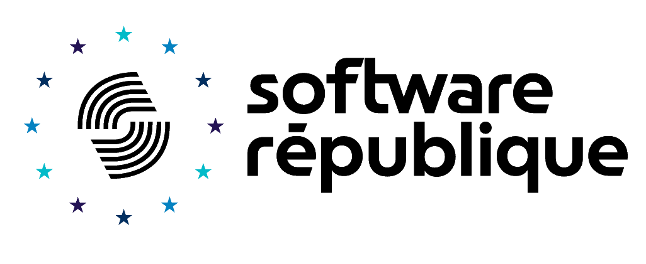
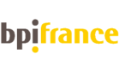
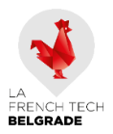
14:30 Brief and presentation of the jury by Jelena Petrovic and François-Xavier Kowandy
14:40 First session: Presentation of 6 start-ups
15:28 Coffee break
15:43 Second session: Presentation of 6 other start-ups
16:31 Jury deliberation
17:00 Announcement of the winners and photo of the 2025 Mission France’s promotion

