Serbian-French Innovation Forum 2025
“AI-deas for a better tomorrow: driving societal change”
April 2nd & 3rd, 2025
Belgrade

April 2, 2025
17:00 – 18:00 Conference “Nikola Tesla: France as inspiration”
Speaker: Aleksandar Protic, École Polytechnique
Palace of Science, Kralja Milana 11
April 3, 2025
Serbian – French Innovation Forum
Palace of Serbia, Bulevar Mihajla Pupina 2
Opening Session
09:00 Registration
09:55 Launch by Ms. Jelisaveta Lazarevic, PhD, FEFA Vice Dean & PIPA Alumni
10:00 Opening speech by H.E. Jelena Begovic, PhD, Minister for Science, Technological Development and Innovation, Republic of Serbia
10:10 Opening speech by H.E. Pierre Cochard, Ambassador of France to Serbia
10:20 Keynote lecture – Ms. Danijela Markovic, CNRS-Thales-Paris-Saclay University « Albert Fert lab »: "Quantum AI or how to teach a quantum machine to compute”
11:00 Coffee break
Roundtables moderated by Jelisaveta Lazarevic, PhD
11:20 - 11:55 Panel n°1 « Artificial Intelligence applications for sustainable and innovative transports »

Speakers:
- Mr. Nenad Mijatovic, PhD, Director of Data Science and AI, Alstom: Focus on public transportation
- Ms. Laurence Bechon, Chief Operating Officer, Software République: Focus on sustainable and connected mobility
- Mr. Aleksandar Bojanic, Regional Director, Airbus: AI satellite apps for better transports
11:55 - 12:30 Panel n°2 « Artificial Intelligence applications for better health »

Speakers:
- Mr. Jean-François Beraud, Chief Innovation Officer, Advans
- Ms. Aleksandra Dragićević, PhD, C4IR, Serbia
- Ms. Karmen Stankov, PhD Professor, University of Novi Sad
12:30 - 13:05 Panel n°3 « Artificial Intelligence applications for energy sector and materials »
Speakers:
- Ms. Caroline Viarouge, Chief Executive Officer, EIT Manufacturing
- Ms. Marijana Milicevic, PhD, R&D project leader, Saint-Gobain
- Ms. Heidi Sen, Head of European partnerships, BPI
13:15 - 14:30 End of the forum and Networking lunch
Mission France
Final Pitch Sessions for 12 finalist startups
Belgrade Science and Technology Park, Veljka Dugosevica 54
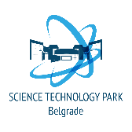
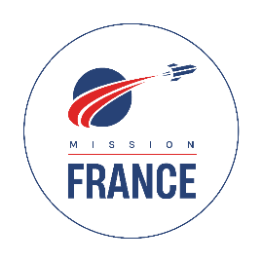
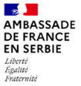
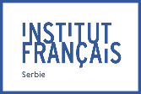

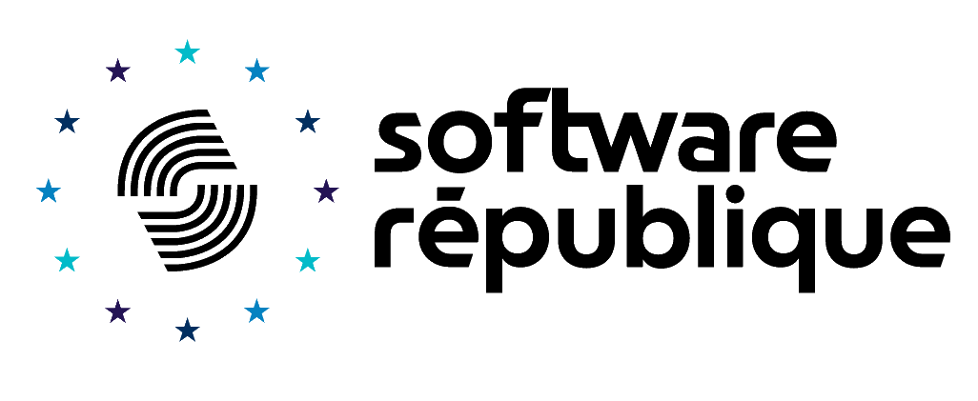
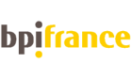
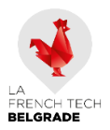
14:30 Brief and presentation of the jury by Jelena Petrovic and François-Xavier Kowandy
14:40 First session: Presentation of 6 start-ups
15:28 Coffee break
15:43 Second session: Presentation of 6 other start-ups
16:31 Jury deliberation
17:00 Announcement of the winners and photo of the 2025 Mission France’s promotion

